# **6 lessons for Data Visualization**

[﻿﻿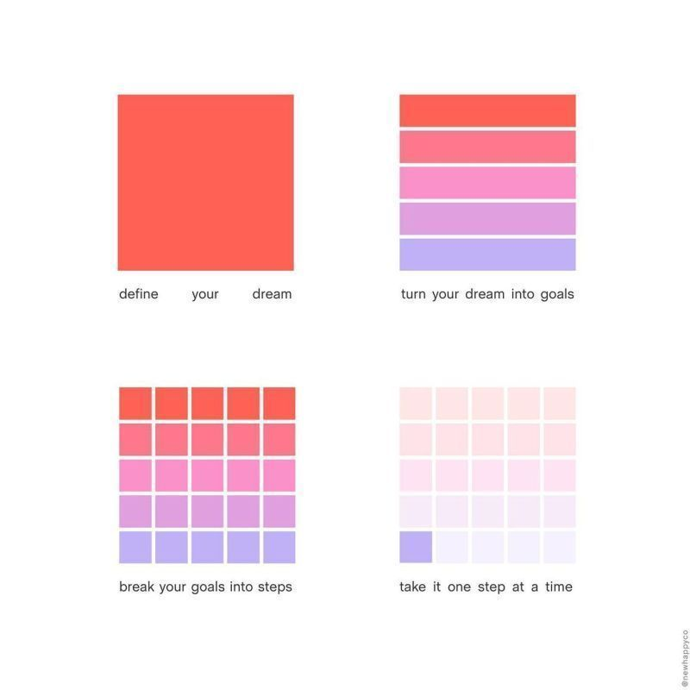](https://www.linkedin.com/posts/eijkelenboom_data-dataviz-activity-6862010795962757121-8-vW)﻿﻿

**6 lessons from this image:  
﻿﻿  
﻿﻿**1. Make it simple  
[﻿﻿](https://www.linkedin.com/posts/eijkelenboom_data-dataviz-activity-6862010795962757121-8-vW)2. The human brain is lazy  
[﻿﻿](https://www.linkedin.com/posts/eijkelenboom_data-dataviz-activity-6862010795962757121-8-vW)3. Take out complexity  
[﻿﻿](https://www.linkedin.com/posts/eijkelenboom_data-dataviz-activity-6862010795962757121-8-vW)4. End-users: "minimal effort = maximum joy"  
[﻿﻿](https://www.linkedin.com/posts/eijkelenboom_data-dataviz-activity-6862010795962757121-8-vW)5. Easy > difficult  
[﻿﻿](https://www.linkedin.com/posts/eijkelenboom_data-dataviz-activity-6862010795962757121-8-vW)6. Simplicity is king  
[﻿﻿  
﻿﻿](https://www.linkedin.com/posts/eijkelenboom_data-dataviz-activity-6862010795962757121-8-vW)I think the message is clear 😉  
[﻿﻿  
﻿﻿](https://www.linkedin.com/posts/eijkelenboom_data-dataviz-activity-6862010795962757121-8-vW)What lesson would you add?  
[﻿﻿](https://www.linkedin.com/posts/eijkelenboom_data-dataviz-activity-6862010795962757121-8-vW)

[﻿﻿  
﻿﻿](https://www.linkedin.com/posts/eijkelenboom_data-dataviz-activity-6862010795962757121-8-vW)Viz source: New Happyco and [Kate Strachnyi](https://www.linkedin.com/in/ACoAAAGZ8KEB1BKU0hGrVAzjgoljBo_7O9T9riY)